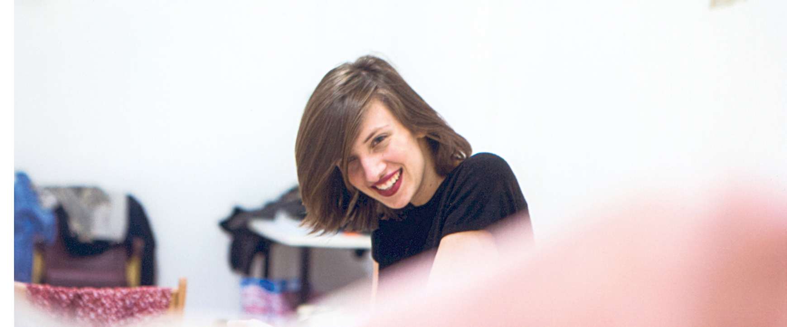
Victoire Bunel
Mezzo-Soprano

Recognised for her great musicality and rich vocal timbre, Victoire Bunel is one of the rising stars of French lyric singing. Her artistic sensibility was developed, to a large extent, at the Maîtrise de Radio France, where she received a full musical and vocal education of the highest quality under the direction of Toni Ramon. She continued her studies at the Département Supérieur for young singers in Paris, at the Royal Academy of Music in London and at the Paris Conservatoire where she received her Master with the honours in June 2018.

Victoire Bunel has marked the last seasons with her debut as Jenny in Die Dreigroschenoper by Kurt Weill at the Shoreditch Town Hall in London, as Théone in Phaéton by Lully with Le Poème Harmonique in Perm (Russia) and at the Opéra Royal in Versailles (c. V. Dumestre, s. B. Lazar), as Sirène in Coronis by Duron at the Opéra-Comique in Paris, as Maria in Maria de Buenos Aires by Piazzolla at the Venice Biennale, as Jean in Le Portrait de Manon by Massenet at Limoges’s Opera, as Paula in Alice’s Mirror by T. Nguyen at the Opera in Reims, as Amando in Le Grand Macabre by Ligeti at Paris Philharmonie with the Ensemble Intercontemporain but also as Siegrune in Die Walküre by Wagner at Bordeaux’s Opera, as Dido in Dido and Aeneas by Purcell at Stift International Festival in the Netherlands, as Karolka in Jenufa by Janacek at the Théâtre du Capitole in Toulouse.
She has also been heard several times at Paris Philharmonie (with Daniel Harding, Matthias Pintscher or Jean-François Hesser), at La Halle aux Grains in Toulouse and at Rouen’s Opera.

The young mezzo-soprano has a special affection for the French melodie and lieder repertoire. She performs frequently in recital with Gaspard Dehaene, Sarah Ristorcelli and Romain Louveau. We have heard Victoire Bunel at the Petit Palais in Paris, at the Compiègne Theatre, at the Théâtre du Capitole in Toulouse, at Lille’s Opera, at the Musée d’Orsay, at the Wigmore Hall in London or several times on the French Radio. Soon, she will give several recitals, with the Winterreise by Schubert with Romain Louveau and Jean-Christophe Lanièce at the Compiègne theatre, and the Théâtre du Beauvaisis. This project will be recording during the summer 2023 for the Label B Records. She will also give recital with French repertoire with Gaspard Dehaene in Montreal (Canada) and in Toulouse (Palais Niel) with Sarah Ristorcelli. She is a regular guest in several international festivals as Kuhmo Chamber Music Festival (Finland), Stift International Music Festival (Netherlands) or at the Biennale in Venice (Italy).

Victoire Bunel news includes the role of Ino in Semele by Händel in Lille’s Opera, Annio in La Clemenza di Tito by Mozart at Rouen’s opera, Lisetta in Il Mondo della Luna by Haydn in Metz Opera, La Voisine in Inondation by Filidei at Opéra-Comique in Paris, Flora in La Traviata by Verdi at the Théâtre du Capitole in Toulouse.
Next season, among others, she will sing Mélisande at the Théâtre du Capitole in Toulouse, Ottavia in L’incoronazione di Poppea by Monteverdi in Rennes Opera, or Fiodor in Boris Godounov by Moussorgski in Théâtre des Champs Elysées and Capitole in Toulouse. She will also sing the Kindertotenlieder by Mahler with orchestra in Porto.

Her first CD, Prima Verba, recorded with Sarah Ristorcelli and with the participation of the Quatuor Elmire, is dedicated to French melodie (Séverac, Fauré and Chausson). We can also find Victoire Bunel on the recording CD and DVD of Phaéton by Lully recorded at the Opéra Royal in Versailles with Le Poème Harmonique, in the CD of the Academy Orsay-Royaumont, Carte Postale under B Records, and in the splendid lamentation by Cavalli in the CD Noces Royales recorded in the Château de Versailles with Le Poème Harmonique.

